


Parents Have Trusted Us for Over 25 Years in Atlantic County!

- Healthy & Safe
- Caring, Educated, & Experienced Staff
- Nurturing & Educational
- Flexible & Affordable
- Fun & Family Focused
Infants * Toddlers * Preschool *PreK

Kayleigh S.- We have been a Kidz Campus family for about 4 years, we love the staff and teachers. They work so hard and love your kids like their own. They are responsive to questions and really want what is best for your child and your family. We would recommend them to any local family.



Jessica C.- We love Kidz Campus. It is a very clean facility. Children are properly cared for, always learning, singing songs, playing, sharing, & coming home with projects. There is so much love here! From the Director, down to each teacher and assistant; they all do a fantastic job!

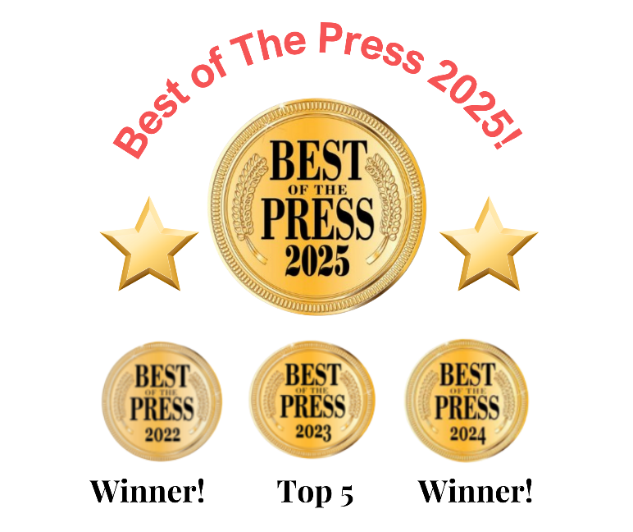

Visit our website to
plan a visit or register




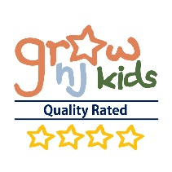
682 White Horse Pike Absecon NJ 08201
www. Kidz-Campus.com * Fun@Kidz-Campus.com


Welcome to Kidz Campus Preschool & Childcare
This School Program Book explains our programs, curriculums,
standards, staff, FAQ and the application process.
What are your hours? We are open Monday – Friday from 7:00 am – 6:00 pm
What ages do you serve? We have childcare and preschool year-round for infants- 5 years of age. We also offer after school care, vacation care and a summer camp for children ages 3-7.
What schedules do you offer? Children may attend 2-5 days a week. You may choose the days your child attends on a set schedule/
School Closings: We are closed for major holidays and staff training days per year. A complete calendar is in the school handbook and on our website.

Are you licensed or affiliated? We are licensed by the NJ Department of Children and Families. We are affiliated with NAEYC and follow their guidelines for developmentally appropriate practices. We also participate in the Grow NJ Kids certification.
Are your staff members educated and trained? Our staff members and teachers are educated and experienced in early childhood education and development. Many hold college degrees and / or CDAs. Monthly training is conducted across a broad range of topics for all staff members.
Ratios: We maintain class sizes and ratios at or below the state of New Jersey rules.
  - 0 - 18 months (1:4)
  - 18 months - 2 1/2 years (1:6)
  - 2 1/2 - 4 years (1:10)
  - 4 years (1:12)
  - 5 years and older (1:15)
Are children of different ages grouped together? Children are grouped into classes based upon their age and developmental level. Children of various ages do come together for special events, parties, trips and opening and closing periods.
Do you welcome parent involvement; can I stop by unannounced? The answer is “YES!” Our school is a community that is open and encourages family participation. We host events throughout the year, including parties, trips, special guest visitors and more! Parents can be involved in many ways.

How do you communicate with parents? Our primary mode of communication is through our school app. All families are enrolled in the program and daily activities, messages, newsletters, and reminders are sent to families via our school app. Families may also send us messages on the school app. Additionally, there are bulletin boards, daily notes, and postings on our social media sites.

How often do you clean the rooms and equipment? All our facilities (including toys) are cleaned multiple times a day. The bathrooms and the changing tables are disinfected continuously over the course of the day.
What are your health policies? In NJ, a complete health assessment form by the child’s primary care provider is required. It is the parent’s responsibility to maintain current health and immunization records. To keep our children, their families, and our staff, as healthy as possible, we require that any child with a fever, vomiting, diarrhea, or contagious disease be kept at home.

Do you have a playground, is there daily outside time? We have a playground on the side of our building. The playground is fenced in for security. In addition to free play, we conduct learning experiences outside on a regular basis. (Weather permitting.)
Do you have STEM & technology tools?
We are proud to offer STEM and technology tools in our program. We introduce Science, Technology, Engineering, and Math (STEM) through fun, hands-on activities designed for curious little minds. Our goal is to spark creativity, critical thinking, and problem-solving skills in an age-appropriate way.
What security measures are in place to protect my child? Your child’s safety and your peace of mind are of the utmost concern. Our entire facility is locked from the outside and the play yard is fenced in. We have automatic smoke and fire detection alarms, and all staff have criminal background checks, fingerprinting, and emergency preparedness training.

How is tuition paid? We are happy to offer our families a childcare software program for easy auto- pay service. Tuition is paid monthly though your bank/checking accounts, this prevents late payments and late fees! Enrollment is simple to do and is FREE! All families are required to use this program.

Who provides meals and snacks? Families provide all meals and snacks for their children. We do offer a daily lunch that may be purchased from neighborhood restaurants.


Is potty training a requirement? Your child DOES NOT have to be potty trained. Preschool admission is not based upon this skill. All children develop at their own pace. Staff members will help parents when it is time to train, and a positive training plan will be implemented!

What is your admissions and EOE policy?
Kidz Campus is a non-discriminatory program committed to fostering respect, inclusion, and understanding for all individuals—regardless of race, culture, religion, gender, sexual orientation, national origin, age, disability, or background.
While we are not a religiously affiliated school, we proudly recognize and celebrate a variety of holidays and traditions that reflect the rich diversity of our students, families, and the broader community.

Our Staff

We are Small by Choice & Offer Superior Teachers!
Kidz Campus has an amazing staff consisting of directors, teachers, and assistants. Our directors are on site and dedicated to assisting your family in whatever needs may be present. Our management team has over 75 years’ combined experience and they are educated and highly skilled professionals.

- Our staff members know all the children and families by name.
- We are a school community that cares for and supports one another.
- Our teachers are educated and experienced.
- Our teachers are trained annually in 1st Aide, CPR and Emergency Plans.
- Many of our staff members have worked together for 5-15 years.
- Many teachers have over 15+ years’ experience!
- Every month our teachers complete continuing education in topics such as child development, best teacher practices, classroom management, curriculum planning, family communication and many more topics.

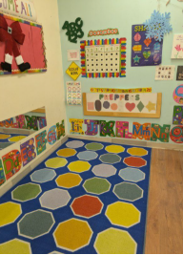
Our Facility

- 5,000 square feet divided into age separated classrooms.
- Open classrooms that are bright, beautiful, and filled with natural light.
- Child centered classrooms designed for education and fun.
- Safety & cleanliness are priorities - Daily disinfecting and cleaning.
- Secured entrance - Our entire facility is locked from the outside and the play yard is fenced in.
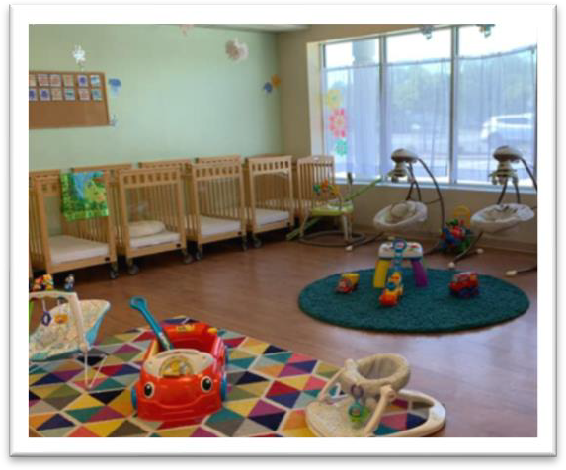
- Fire and sprinkler alarm system- We have automatic smoke and fire detection alarms and monthly fire drills, and emergency evacuation plans are conducted.

Our Learning Philosophy
How we Learn
Our program is a balance of academic instruction and play based activities. Our program is designed upon the philosophies of Montessori, Piaget, and Reggio-Emelia. We follow NAEYC’s developmentally appropriate guidelines.

The “whole child” approach
The primary goal of our educational programs is to help each child reach their full potential in ALL areas of development and develop a love for learning.

The “prepared environment”
For self-directed learning to take place, the environment must be supportive for active learning. This enables the child to try new things and build self-confidence.

Classroom materials and structure
The materials are developmentally appropriate, organized, and accessible to teachers and children.

The teacher

The teacher functions as a facilitator of learning; she is a role model, demonstrator, and observer. She has open communication and supportive relationships with families.

Learning Fun & Special Events Every year we have tons of extra special days and activities such as:
- Raising butterflies and watching them hatch!
- Holiday parties.
- Pumpkin patch trip.
- Firefighter visit.
- Earth Day celebration.
- Dr. Seuss Birthday
- Summer Luau.

Community Involvement

Each month, our children participate in our Caring & Sharing curriculum that teaches empathy and compassion. We select a charitable cause and donate time or items, to support those in need. Through these hands-on experiences, children learn the importance of kindness, empathy, and helping others. Over the years, we’ve contributed to many wonderful organizations, including:

- Alex's Lemonade Stand
- The Food Bank of South Jersey
- Atlantic County Women's Shelter
- Children’s Hospital of Philadelphia

Academic Programs

The Creative Curriculum
The Creative Curriculum balances both teacher-directed and
child-initiated learning, with an emphasis on responding to children's learning styles and building on their strengths and interests. It is one of the country's leading research-based
preschool curricula and applies the latest theory and research on best practices in teaching and learning, additionally it applies standards developed by states and professional organizations.
Read more here: www.teachingstrategies.com

Problem Solvers STEM Curriculum
(Science, Technology, Engineering, and Math)
Our Problem Solvers Program introduces children to Science, Technology, Engineering, and Math through hands-on, playful learning. Kids build, explore, experiment, and solve real-world problems. Each week, they become mini engineers and scientists, learning how things work and discovering the joy of asking “what if?” Our STEM lessons are woven into everyday learning, and additionally we have technology tools for our preschool aged children.




Tiny Signs – Baby Sign Language
At Kidz Campus, we incorporate Tiny Signs, a baby sign language program, into our infant and toddler curriculum. Signing helps babies express their needs before they can speak, leading to:
- Improved communication and reduced frustration
- Advanced language development and stronger vocabulary.
- Higher cognitive abilities, with research showing higher average IQs.
- A deeper connection between caregiver and child as we better understand their interests and personality.
Helping little ones feel connected and understood
from the very beginning.

Our Preschool & Prekindergarten Curriculum

Our curriculum is designed to ensure that children acquire measurable learning objectives across the year that are developmentally appropriate for three-year old to five-year old. The learning objectives are broken down into specific, measurable, and sequential skills that are incorporated into the curriculum. Specific skills and concepts are targeted on a weekly and monthly basis in a fun and engaged manner.


Social and Emotional Development
- Develop self confidence in one's intrinsic value and skills
- Learning independence and separation from family
- Ability to communicate with verbal skills
- Develop healthy relationships with children and adults
- Learn to share, take turns, and join in group play
- Learn appropriate skills to deal with social conflict

Reading Readiness
- Identifying capital and some lower-case letters
- Associating letters and sounds
- Learn to enjoy books, poems, and stories
- Predicting what happens next in stories and books
- Recognize the meaning of signs and symbols

Writing Readiness
- Ability to make lines, circles, and basic writing shapes
Lindsey A.
My 3.5-year-old has been going to Kidz Campus for over a year now. At such a pivotal age, I have seen my child develop new skills in the curriculum-based program they offer. Any issues have been clearly communicated and handled with genuine care. I'm always impressed with how clean the facility is. We love all the teachers and directors. I'm excited to enroll my 1-year-old as I transition back to work, we wouldn't consider anybody else!

- Ability to print name and basic sight words
- Knowledge of left-to-right and top-to-bottom of paper
- Using a correct grip with pencil, crayons, markers, and pens

Math & Logic Readiness
- Recognizing numbers 1-20
- Counting sequentially 1-20
- Matching numbers to values
- Calendar skills
- Ability to sort and classify objects
- Ability to use simple graphs
- Ability to follow and create patterns
- Understand directional words
- Recognizing and naming basic shapes
- Recognizing and naming basic 3-D shapes
- Measurement and time basics
- Understand basic money concepts

Science and Health
- Knowledge of self and self-care
- Value nutrition and exercise
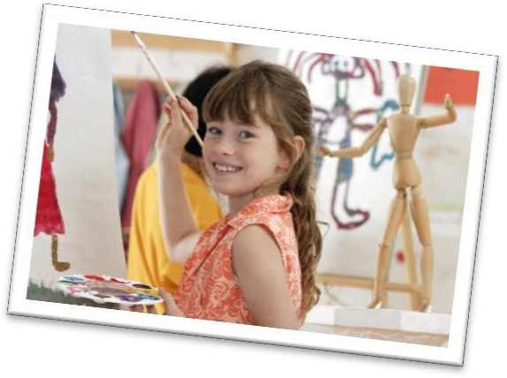
- Knowledge of nature and seasons
- Developing awareness of the five senses
- Knowledge of animals and their homes
- Understand basics of outer space
- Knowledge of weather
- Basic skills with science equipment

Art
    - Recognizing the colors
    - Self-expression through art
    - Recognition of art mediums and styles
    - Creative representation of skills learned

Music
  - Learn basic songs and finger plays
  - Knowledge of rhythm and sound
  - Knowledge of different styles of music
  - Understanding music styles from different cultures
  - Recognize instruments’ sounds and names

During the Prekindergarten school year, the students also work on mastering the following skills:

- Sight word recognition
- Beginning phonics abilities
- Beginning reading (2-4-word sentences)
- Computer skills
- Conduct simple science experiments, form theories and hypothesis
- Basic addition and subtraction
- Awareness of basic world geography and cultures

Kristina D.
I highly recommend Kidz Campus. My son has been there for almost 2 years and absolutely loves it and their staff is great! It is a very safe environment, and their educational foundation is great! My son constantly amazes me with the things he has learned.

Toddler & Prepper Time: Our Toddler / Prepper Curriculum

    - The first three years of life are a time of incredible growth and development. Our program facilitates emotional, social, physical, and intellectual growth for our youngest friends.
    - The curriculum is designed to ensure that children acquire measurable learning objectives across the year. Specific skills and concepts are targeted on a weekly and monthly basis. The curriculum focuses upon developmentally appropriate goals for 1 ½ year old to three-year-old.
    - The learning objectives are broken down into specific, measurable, and sequential skills that are incorporated into the curriculum.

Art Development
    - Enjoys exploring art materials and their usage, including crayons, paints, paste, brushes
    - Uses paste and other art media effectively


Language Development and Reading Readiness
    - Begins to recognize colors and alphabet letters
    - Develops a larger vocabulary through stories and discussion
    - Participates in oral discussions
    - Knows own name, the teacher’s name, and some classmate’s names
    - Speaks clearly
    - Speaks in sentences
    - Recognizes first name
    - Recognizes majority of upper-case letters
    - Knows 8 basic colors

Math Readiness and Science
    - Counts to 10
    - Recognizes the numbers 1 -10
    - Recognizes such geometric shapes as circles, squares, and triangles
    - Enjoys experimenting
    - Shows an interest in the world around him/her
    - Correspondence
    - Basic Patterning
    - Basic Seriates

Music Development
    - Enjoys listening to music
    - Participates in musical activities
    - Enjoys using musical instruments

Physical Development
- Large muscle development (running, hopping, jumping)
- Learns to communicate and master bathroom needs effectively
- Shows dominant hand.
- Holds pencil and crayon correctly

- Demonstrates hand-eye coordination puzzles, stringing)
- Fine muscle development (cutting, coloring, pasting)

Socio-Emotional Adjustment and Personal Habits
- Learns to adjust to new situations
- Enjoys being at school
- Gets along with other children
- Has positive self-image
- Follows classroom rules
- Shows respect for own and other belongings
- Willing to try new activities

Learning Habits
- Listens attentively
- Follows directions

- Puts forth effort
- Cares for materials
Ashlie J,
My son is 2 and he has been going here since he was 6 months old. He LOVES school and all his teachers, and I can tell that they truly care about him. The staff at Kidz Campus are great at providing individualized attention to kids

Bright Baby: Our Infant Program & Objectives
Amber H. Could not be happier with our experience in the infant room so far! Our daughter is 6 months old and has been attending for a few weeks. Communication with staff has been great and we love the daily picture updates they send. Our daughter always seems happy and well cared for, which has made my transition back to work much easier. It’s clear the staff and director care very much about all the children.

The Bright Baby Program
Individualized attention and partnerships with parents are
The cornerstones of the Bright Baby program. Your baby
will have days spent with nurturing caregivers, and plenty
of learning opportunities. Each baby is cared for based
upon their unique needs, a schedule will be developed
through parent / teacher planning so that your baby is
well rested, fed, and loved!

The Caregivers
Our staff is focused on keeping your baby happy, engaged,
and secure. Your baby will have 1-2 primary caregivers.

There are also always teaching assistants and directors on
site if extra TLC is required.

Your Baby’s Day
Each baby is cared for based upon their unique schedule and needs. Every day has a varied amount of quiet time, rest time, play time, and learning time.

Communication & Care
Every day your baby’s caregivers will record their learning activities, their sleep schedule, diaper and eating activity. You will also be informed of your baby’s.
mood and any concerns such as teething or changing food preferences. The teachers will let you know any needed items; when it is time to restock diapers, change of clothes or any other personal needs.

Bright Baby’s Learning & Development
Every day, your baby will have the opportunity to learn and develop through age-appropriate activities and experiences. The nursery, in addition to having rest and feeding areas, also has several learning areas devised just for the babies in our care. Every day, your baby will have the following:

- Storytime
- Music time
- Gross motor development (crawling, walking, dancing, ball play)
- Fine motor development (holding spoons, crayons, reaching)
- Sensory and art exploration (coloring, paint, dough, water)
- Language development (letters, speech, visual representation)
- Baby signs (sign language for communication & language

School Tuition & Fees
- There is a $150.00 registration fee per family annually.
- Tuition is paid monthly by the 25th of the upcoming tuition month.
- All families are required to enroll in our auto pay program.
- There is a 5% sibling discount.

NJ Childcare Tuition Assistance
In NJ a large amount of this money has been targeted to help families pay for high quality childcare We urge all families to discover if they may qualify. We have a lot of experience helping so please do not hesitate to ask one of our directors for some guidance. We are here to help you!

""
The Enrollment Process

Kidz Campus Preschool & Childcare – Joining our School Family

We are so happy you’re considering Kidz Campus for your family! As a family-owned and operated center, we have proudly served the Absecon community since 2011—and our roots go back even further through The Little Learners Centers that we operated in Brigantine and Absecon since 1995.

We know that choosing childcare is a big decision. Every child and family is unique—and not every program is the right fit for everyone. That’s why we believe in creating strong, supportive partnerships with the families we serve.

As part of our enrollment process, we invite you to schedule a tour and a brief 15–20 minute family meeting. This gives us a chance to get to know your child and family better—and for you to spend a little time in our program, ask questions, and see if we’re the right match.

Enrollment Steps:
- Visit our website or call to request our School Program Book.
- Schedule a tour.
- Plan a family application meeting, (can be done the day of your tour.)
- Complete the application packet.
- Enroll in our online management system.
- Get ready to join our Kidz Campus family!

